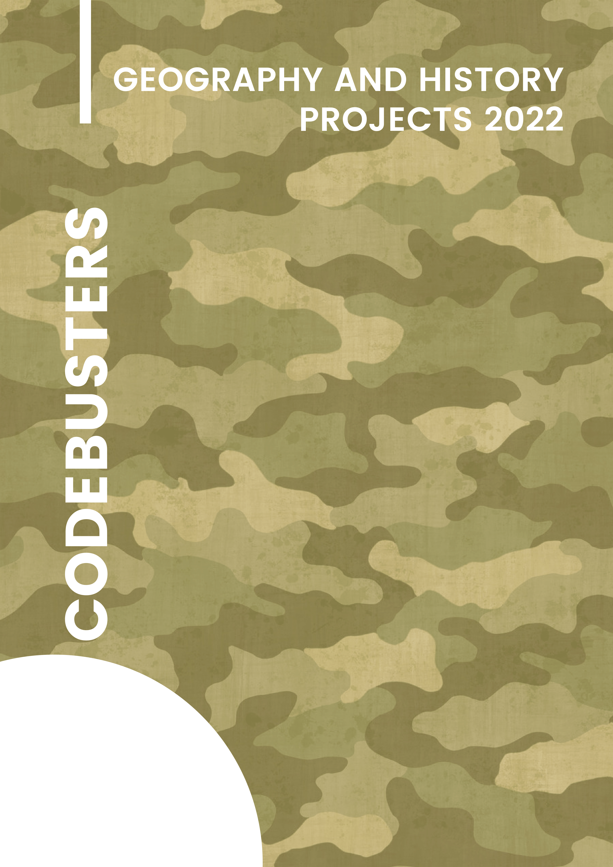

Contents

1. Project theme 2
2. Team 2
   1. Iliyana Michevska 9A – Developer Front-end 2
   2. Vanesa Kardzheva 9A – Developer Back-end 2
   3. Elena Keserzhieva 9A – Designer 2
   4. Elina Genova 9A – Scrum trainer 2
3. Resume 2
   1. Goals 2
   2. Progress 2
   3. Realization 2
      * + 1. Used technology – color scheme, fonts!!,…...2
          2. Sources 2
   4. Our site -- DIAGRAMA 2
   5. Quiz game - photo 2
   6. War game - photo 2
4. Conclusion 2
   1. solutions 2
   2. Future ideas 2
5. Theme of the project

The theme of our project is the historical and geographical implications of World War One. We wanted to focus on sharing useful information about this important but tragic war.

1. Team
   1. Iliyana Michevska 9A – Developer Front-end
   2. Vanesa Kardzheva 9A – Developer Back-end
   3. Elena Keserzhieva 9A – Designer
   4. Elina Genova 9A – Scrum trainer
2. Resume
   1. Goals

One of the main goals of our project was creating an informational site with which the user can learn new things about World War One. We did that in an interactive way - a folder which shows 3 sections, changing pictures about fronts and a real letter. The site also has custom scrollbar and custom cursor.

Besides the site, we also made a quiz game with which the user can test their knowledge. The game has a 2-player mode and assets made by us.

We also have a World War One themed shooter game. The user plays as Germany - they shoot their opponents with a weapon.

